Crossed Pentagonal Cuploid

Definition
# Source: AI Source: Provided by: [Data Path: Persons Table -> ID Column: 1, Name_En Column: Motasem Essam] -> From: [ChatGPT] on [7/25/2026]
A Crossed Pentagonal Cuploid, also known as a $\{5/4\}$-Cuploid or Crossed Pentagonal Semicupola, is a specialized non-orientable polyhedral construction belonging to the cuploid family.
It is formed using a retrograde pentagonal arrangement, five square faces, and five triangular faces. Its lower polygonal base becomes degenerate and is removed, allowing the triangular and square faces to connect directly.
Unlike the Pentagrammic Cuploid $\{5/2\}$, the Crossed Pentagonal Cuploid does not require a separate central membrane.
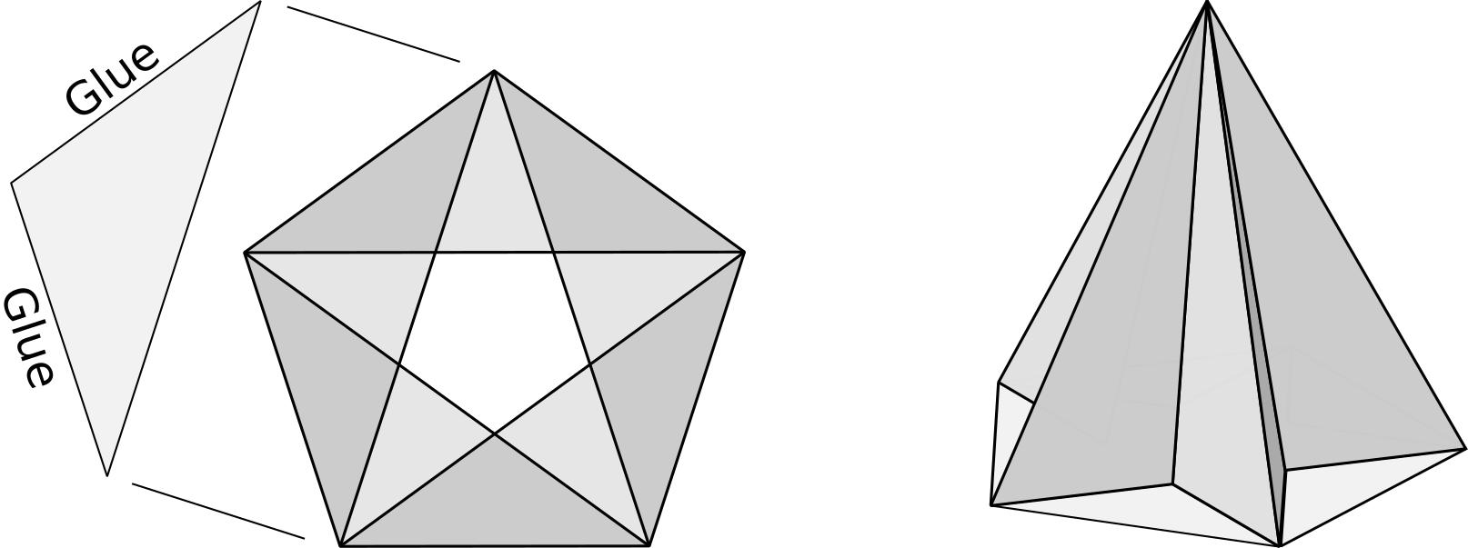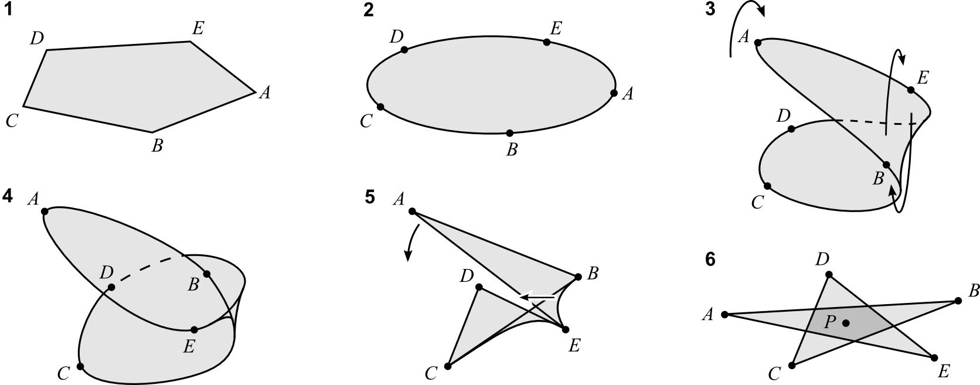

Simple Definition
# Source: AI Source: Provided by: [Data Path: Persons Table -> ID Column: 1, Name_En Column: Motasem Essam] -> From: [ChatGPT] on [7/25/2026]
A Crossed Pentagonal Cuploid is a three-dimensional non-orientable geometric structure made from five triangular faces, five square faces, and a retrograde pentagonal arrangement, with its degenerate lower base removed.

Geometric Structure
# Source: AI Source: Provided by: [Data Path: Persons Table -> ID Column: 1, Name_En Column: Motasem Essam] -> From: [ChatGPT] on [7/25/2026]
Its star-polygon notation is:
$$\boxed{\{5/4\}}$$
This notation means:
- 5 represents five vertices.
- 4 represents the step size used when connecting the vertices.
- Each vertex connects to the vertex four positions ahead.
- The resulting pentagonal traversal is retrograde: it follows the ordinary pentagon in the opposite direction.
- The corresponding lower base is a degenerate polygon, represented by $\{10/4\}$.
- The degenerate lower base is removed, and the triangular and square faces connect directly.
The $\{5/4\}$ arrangement has the same pentagonal outline as an ordinary pentagon, but its vertex traversal is reversed.
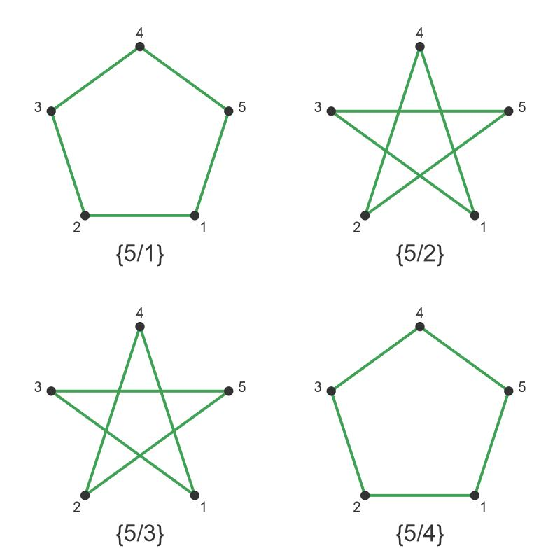

Face Structure
# Source: AI Source: Provided by: [Data Path: Persons Table -> ID Column: 1, Name_En Column: Motasem Essam] -> From: [ChatGPT] on [7/25/2026]
The Crossed Pentagonal Cuploid has 11 faces.
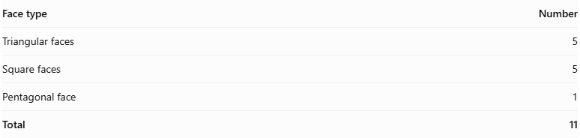
Face type | Number
Triangular faces | 5
Square faces | 5
Pentagonal face | 1
Total | 11
The five triangular and five square faces form the lateral structure. The pentagonal face is associated with the upper polygonal boundary.

Edge Structure
# Source: AI Source: Provided by: [Data Path: Persons Table -> ID Column: 1, Name_En Column: Motasem Essam] -> From: [ChatGPT] on [7/25/2026]
The standard Crossed Pentagonal Cuploid has:
- 20 edges.
- Edges shared between adjoining triangular and square faces.
- Five edges associated with the pentagonal boundary.
- A crossed arrangement resulting from the retrograde polygonal construction.

Vertex Structure
# Source: AI Source: Provided by: [Data Path: Persons Table -> ID Column: 1, Name_En Column: Motasem Essam] -> From: [ChatGPT] on [7/25/2026]
It has 10 vertices.
These vertices form two groups of five:
- Five vertices associated with the pentagonal boundary.
- Five vertices associated with the lower connections of the triangular and square faces.
The two groups are connected through the lateral face arrangement.

Mathematical Properties
# Source: AI Source: Provided by: [Data Path: Persons Table -> ID Column: 1, Name_En Column: Motasem Essam] -> From: [ChatGPT] on [7/25/2026]
Geometric data
11
Faces
20
Edges
10
Vertices
Non-orientable
Surface property
Euler characteristic:
$$V-E+F=10-20+11=1$$
The Euler characteristic of 1 is consistent with the non-orientable surface topology of this cuploid.

Why It Does Not Have a Membrane
# Source: AI Source: Provided by: [Data Path: Persons Table -> ID Column: 1, Name_En Column: Motasem Essam] -> From: [ChatGPT] on [7/25/2026]
An important difference between this solid and the Pentagrammic Cuploid is the presence or absence of a central membrane.
- The Crossed Pentagonal Cuploid uses $\{5/4\}$.
- Its ratio is $5/4=1.25$, which is less than 2.
- Its triangular and square faces cover the underside.
- Therefore, no separate central membrane is needed.
By comparison, the Pentagrammic Cuploid $\{5/2\}$ has a ratio greater than 2 and requires a membrane.
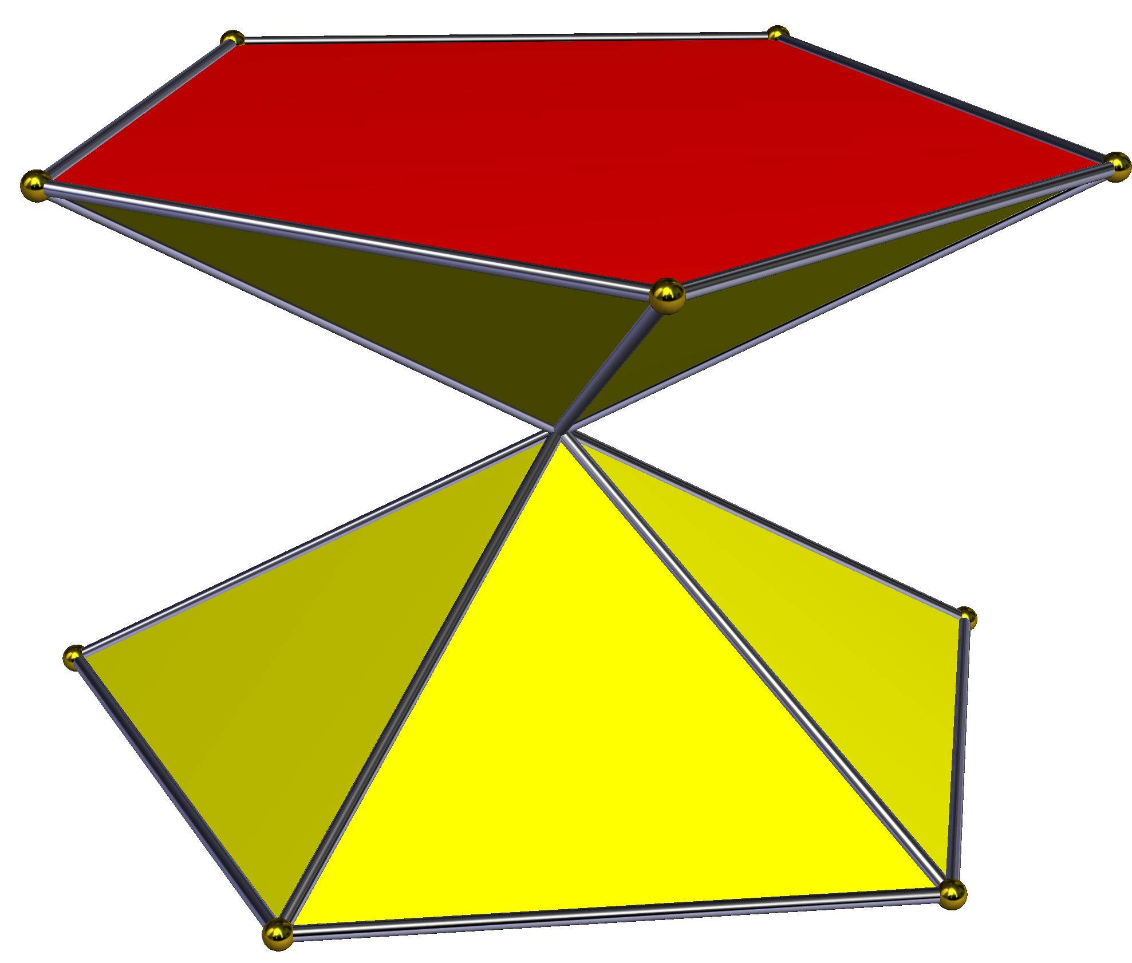
Crossed Pentagonal Cuploid
No membrane
{5/4}
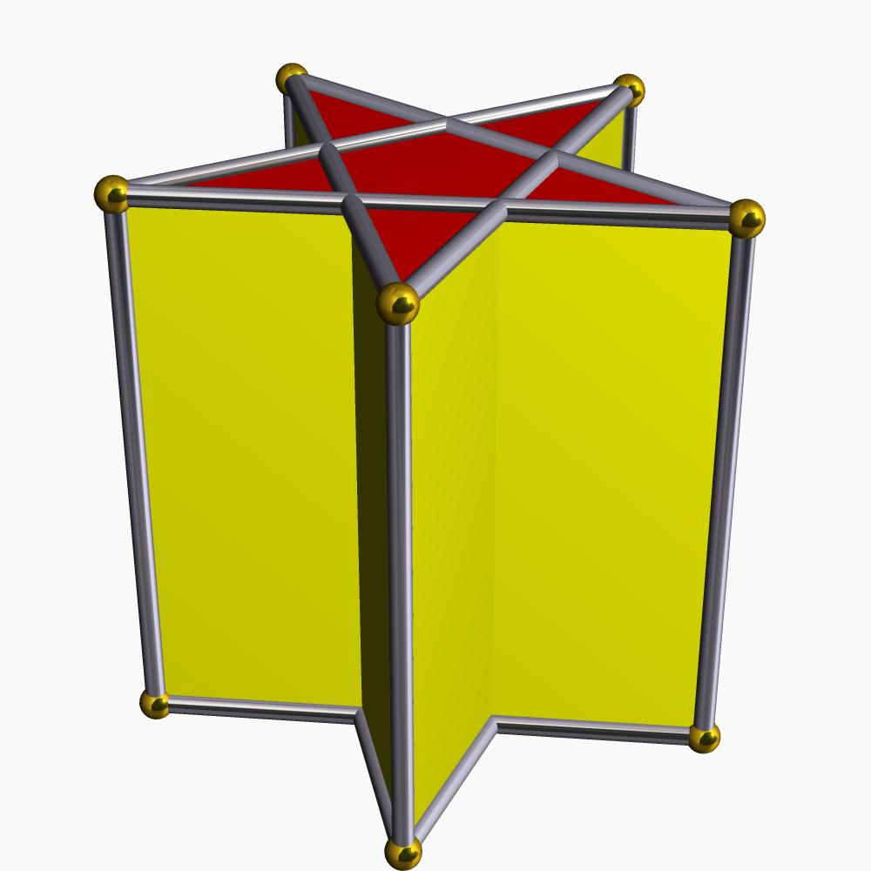
Pentagrammic Cuploid
Has membrane
{5/2}

Symmetry
# Source: AI Source: Provided by: [Data Path: Persons Table -> ID Column: 1, Name_En Column: Motasem Essam] -> From: [ChatGPT] on [7/25/2026]
The regular Crossed Pentagonal Cuploid has:
- Fivefold rotational symmetry.
- Five vertical reflection planes.
- Symmetry group $C_{5v}$.
- Rotation group $C_{5}$.
These symmetries arise from its fivefold pentagonal arrangement.

Dual Polyhedron
# Source: AI Source: Provided by: [Data Path: Persons Table -> ID Column: 1, Name_En Column: Motasem Essam] -> From: [ChatGPT] on [7/25/2026]
The dual of the Crossed Pentagonal Cuploid is called the Crossed Pentagonal Keratinoid.
Its faces consist of:
- Five kite-shaped faces.
- Five antiparallelogram-shaped faces.
The dual relationship exchanges vertices and faces while preserving their incidence structure.

Relationship to Other Solids
# Source: AI Source: Provided by: [Data Path: Persons Table -> ID Column: 1, Name_En Column: Motasem Essam] -> From: [ChatGPT] on [7/25/2026]
The Crossed Pentagonal Cuploid belongs to the family of cuploids.
Other examples include:
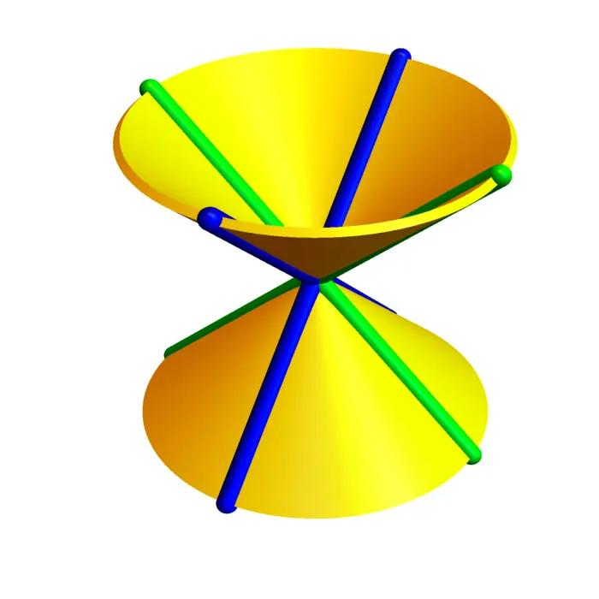
Crossed Triangular Cuploid
{3/2}
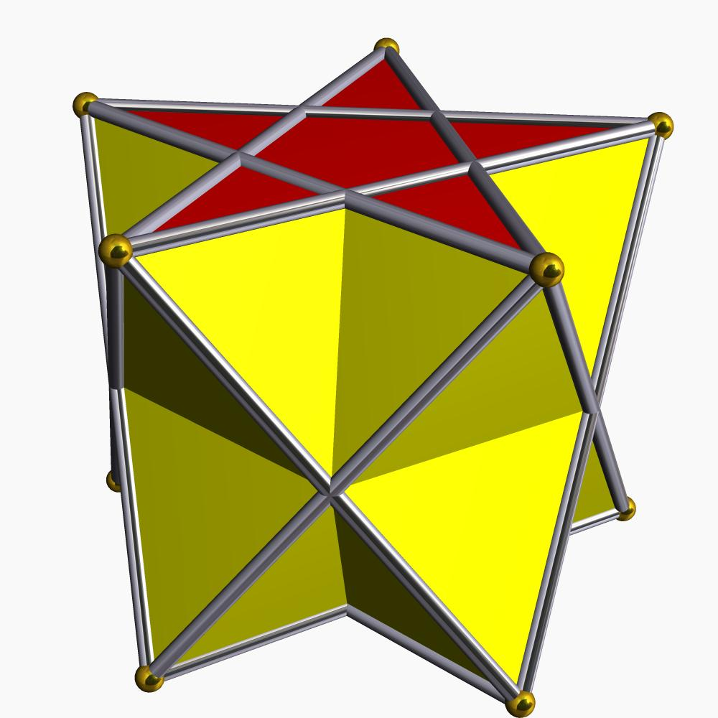
Pentagrammic Cuploid
{5/2}
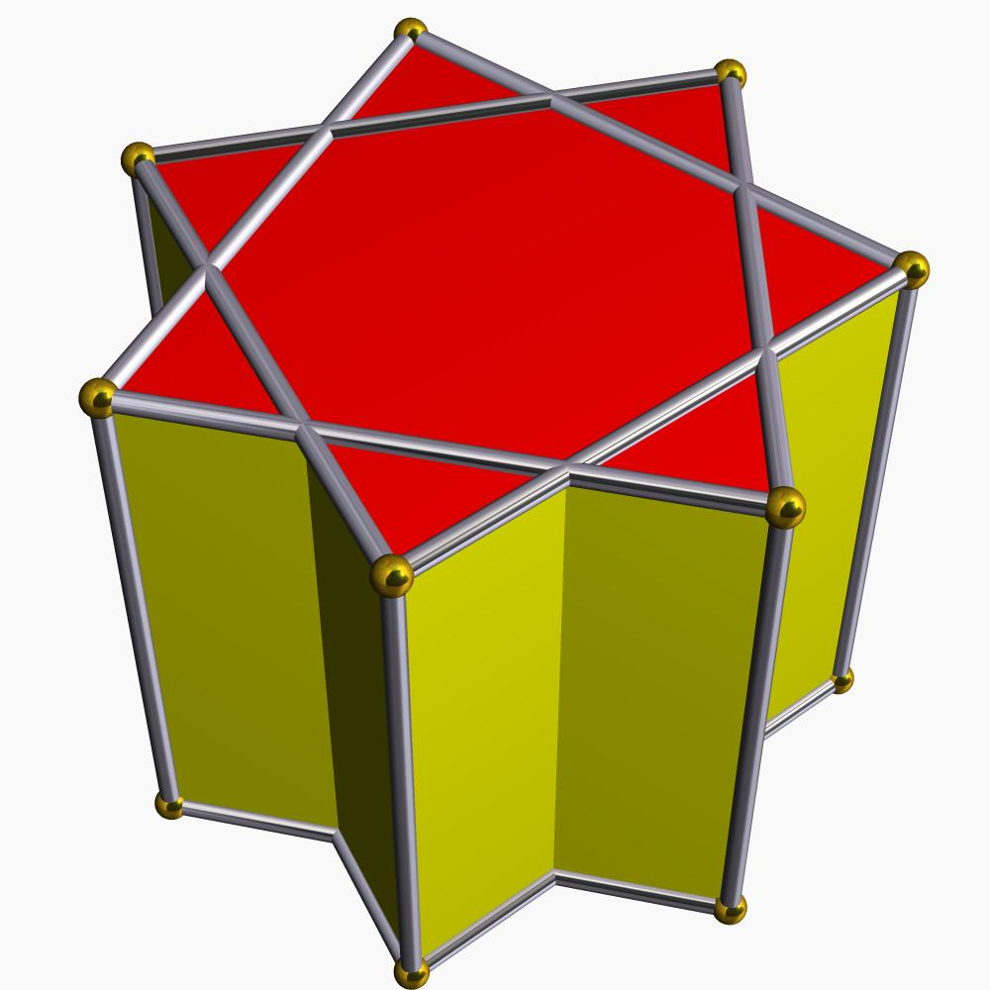
Heptagrammic Cuploid
{7/2}
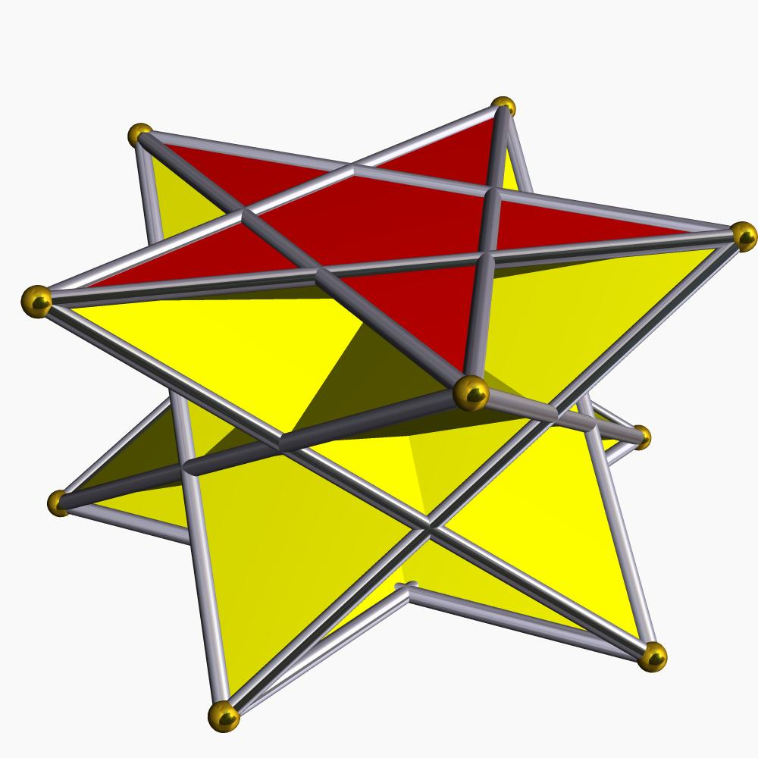
Crossed Pentagonal Cuploid
{5/4}
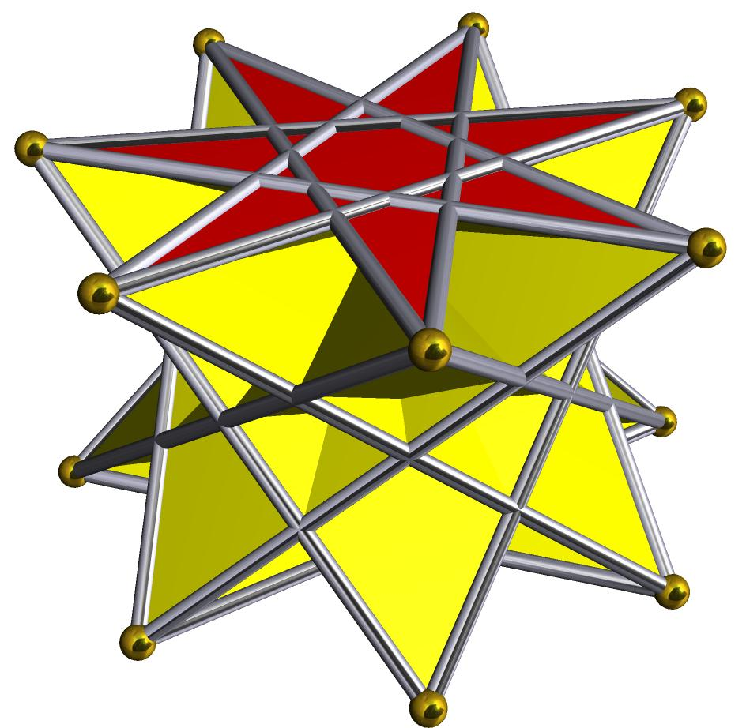
Crossed Heptagrammic Cuploid
{7/4}

Construction of a Crossed Pentagonal Cuploid

Geometric Instruments Used
# Source: AI Source: Provided by: [Data Path: Persons Table -> ID Column: 1, Name_En Column: Motasem Essam] -> From: [ChatGPT] on [7/25/2026]
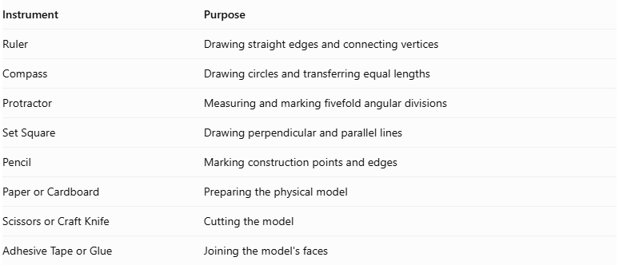
Instrument | Purpose
Ruler | Drawing straight edges and connecting vertices
Compass | Drawing circles and transferring equal lengths
Protractor | Measuring and marking fivefold angular divisions
Set Square | Drawing perpendicular and parallel lines
Pencil | Marking construction points and edges
Paper or Cardboard | Preparing the physical model
Scissors or Craft Knife | Cutting the model
Adhesive Tape or Glue | Joining the model's faces

Instrument-Based Construction Procedures

Constructing the Pentagonal Face
# Source: AI Source: Provided by: [Data Path: Persons Table -> ID Column: 1, Name_En Column: Motasem Essam] -> From: [ChatGPT] on [7/25/2026]
- Draw a circle using a compass.
- Mark five approximately equally spaced points around its circumference using a protractor.
- Label the points $A,B,C,D,E$ in circular order.
- Construct the pentagonal outline.
- Identify the reverse traversal order corresponding to $\{5/4\}$.
- Mark the pentagonal face as the central reference for the cuploid construction.
The angular interval between consecutive vertices is:
$$θ=\frac{{360}^{°}}{5}={72}^{°}$$
The $\{5/4\}$ notation means that each connection advances four vertex positions, equivalent to one position backward around the pentagon.

Constructing the Five Square Faces
# Source: AI Source: Provided by: [Data Path: Persons Table -> ID Column: 1, Name_En Column: Motasem Essam] -> From: [ChatGPT] on [7/25/2026]
- Prepare five square faces with matching edge lengths.
- Arrange them around the pentagonal structure according to the cuploid's face-adjacency pattern.
- Match their edges to the appropriate pentagonal and triangular boundaries.
- Check that the squares follow the fivefold rotational arrangement.

Constructing the Five Triangular Faces
# Source: AI Source: Provided by: [Data Path: Persons Table -> ID Column: 1, Name_En Column: Motasem Essam] -> From: [ChatGPT] on [7/25/2026]
- Prepare five triangular faces.
- Match their edges to the corresponding square-face boundaries.
- Arrange the triangles between the appropriate square connections.
- Check that each triangular face is connected to the intended neighboring faces.

Connecting the Faces
# Source: AI Source: Provided by: [Data Path: Persons Table -> ID Column: 1, Name_En Column: Motasem Essam] -> From: [ChatGPT] on [7/25/2026]
- Arrange the pentagonal, square, and triangular faces according to the Crossed Pentagonal Cuploid structure.
- Identify the degenerate $\{10/4\}$ base arrangement.
- Remove the degenerate base rather than treating it as an ordinary decagonal face.
- Connect the triangular faces directly to the square faces along the corresponding edges.
- Preserve the crossed pentagonal arrangement.
- Verify that every edge has the intended face adjacency.

Completing the Solid Drawing
# Source: AI Source: Provided by: [Data Path: Persons Table -> ID Column: 1, Name_En Column: Motasem Essam] -> From: [ChatGPT] on [7/25/2026]
- Draw the visible edges using continuous lines.
- Draw hidden edges using dashed lines where appropriate.
- Distinguish the pentagonal, triangular, and square faces.
- Check the fivefold symmetry.
- Inspect the complete structure for missing or incorrectly joined edges.
Construction note: The model must follow the cuploid's actual face-adjacency structure. It should not be treated as an ordinary pentagonal cupola with two separate polygonal bases.

Key Points
# Source: AI Source: Provided by: [Data Path: Persons Table -> ID Column: 1, Name_En Column: Motasem Essam] -> From: [ChatGPT] on [7/25/2026]
- The Crossed Pentagonal Cuploid is represented by $\{5/4\}$.
- It is also called the Crossed Pentagonal Semicupola.
- It belongs to the cuploid family.
- It contains five triangular faces and five square faces.
- It has one pentagonal face.
- It has 11 faces, 20 edges, and 10 vertices.
- It is non-orientable.
- It does not require a central membrane.
- Its dual is the Crossed Pentagonal Keratinoid.

Conclusion
# Source: AI Source: Provided by: [Data Path: Persons Table -> ID Column: 1, Name_En Column: Motasem Essam] -> From: [ChatGPT] on [7/25/2026]
The Crossed Pentagonal Cuploid is a specialized non-orientable polyhedral construction based on a retrograde pentagonal arrangement. Its combination of five triangular faces, five square faces, and a removed degenerate lower base makes it an interesting example of advanced solid geometry and polyhedral topology.
References:
- Software3D – Crossed Pentagonal Cuploid.
- Crossed Pentagonal Cuploid – Geometric properties.
- Semicupolas – Cuploid construction and membranes.

